Difficult samples description

1. Multiple contrast samples

air = SLD(0, name="Air")

D2O = SLD(6.3, name = "D20")

layer1 = SLD(2, name="Layer 1")(thick=50, rough=6)

layer2 = SLD(1.7, name="Layer 2")(thick=15, rough=2)

layer3 = SLD(0.8, name="Layer 3")(thick=60, rough=2)

layer4 = SLD(3.2, name="Layer 4")(thick=40, rough=2)

layer5 = SLD(4, name="Layer 5")(thick=18, rough=2)

substrate = SLD(2.047, name="Substrate")(thick=0, rough=2)

structureair = substrate | layer1 | layer2 | layer3 | layer4 | layer5 | air

structureD2O = substrate | layer1 | layer2 | layer3 | layer4 | layer5 | D2O

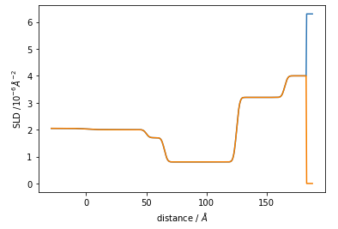

1. Thin layer samples

air = SLD(0, name="Air")

layer2 = SLD(6, name="Layer 1")(thick=6, rough=2)

layer1 = SLD(4, name="Layer 2")(thick=200, rough=2)

substrate = SLD(2.047, name="Substrate")(thick=0, rough=2)

structure = air | layer1 | layer2 | substrate

#Make a model structure

air = SLD(0, name="Air")

layer3 = SLD(5, name="Layer 3")(thick=30, rough=6)

layer2 = SLD(6, name="Layer 2")(thick=6, rough=2)

layer1 = SLD(4, name="Layer 1")(thick=200, rough=2)

substrate = SLD(2.047, name="Substrate")(thick=0, rough=2)

structure = air | layer1 | layer3 | layer2 | substrate

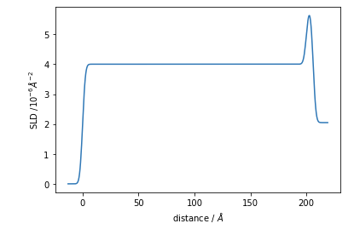

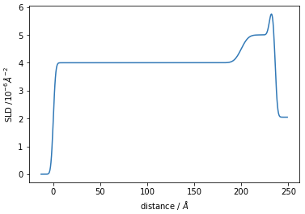

1. Similar SLD samples

air = SLD(0, name="Air")

layer3 = SLD(5.5, name="Layer 3")(thick=30, rough=6)

layer2 = SLD(6, name="Layer 2")(thick=35, rough=2)

layer1 = SLD(3, name="Layer 1")(thick=50, rough=2)

substrate = SLD(2.047, name="Substrate")(thick=0, rough=2)

structure = air | layer1 | layer3 | layer2 | substrate

air = SLD(0, name="Air")

layer3 = SLD(1, name="Layer 3")(thick=50, rough=6)

layer2 = SLD(6, name="Layer 2")(thick=15, rough=2)

layer1 = SLD(0.9, name="Layer 1")(thick=80, rough=2)

substrate = SLD(2.047, name="Substrate")(thick=0, rough=2)

structure = air | layer1 | layer3 | substrate

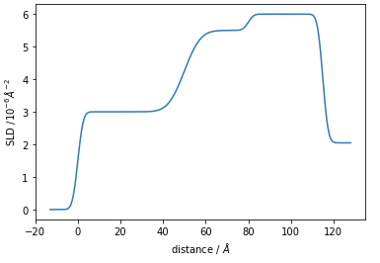

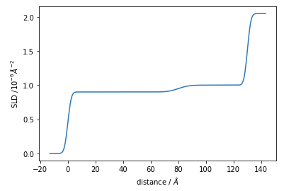

1. Many parameter samples

air = SLD(0, name="Air")

layer1 = SLD(2, name="Layer 1")(thick=50, rough=6)

layer2 = SLD(1.7, name="Layer 2")(thick=15, rough=2)

layer3 = SLD(0.8, name="Layer 3")(thick=60, rough=2)

layer4 = SLD(3.2, name="Layer 4")(thick=40, rough=2)

layer5 = SLD(4, name="Layer 5")(thick=18, rough=2)

substrate = SLD(2.047, name="Substrate")(thick=0, rough=2)

structure = air | layer1 | layer2 | layer3 | layer4 | layer5 | substrate

